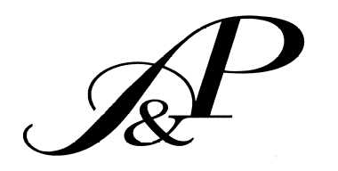
Ashton & Price, LLP

Attorneys at Law
8243 Greenback Lane. Fair Oaks, CA 95628

(916) 786-7787 www.ashtonandprice.com
(916) 786-7625 Fax {{preparer_email}}

FAX COVER SHEET

To: {{carrier_name}} From: {{signer_name}}

Fax #: {{carrier_fax}} Page(s): 1 (including cover page)

Date: {{date_numeric}} RE: Claim # {{claim_number}}

MESSAGE:

Please forward a copy of the dec page as soon as possible. My email is {{preparer_email}}.

Thank you for your anticipated courtesy and cooperation in this matter. If you have any questions, please feel free to contact me at (916) 786-7787.

CONFIDENTIALITY NOTICE
The information contained in this FAX message is intended only for the individual or entity named above. The transmission may contain information that is privileged, confidential, and/or otherwise exempt from disclosure under applicable law. If the reader of this message is not the intended recipient or the employee or agent responsible for delivering this message to the intended recipient, any disclosure, dissemination, distribution, copying, or other use of this communication or its substance is prohibited. If you have received this transmission in error, please call us to arrange for the destruction or return of this transmission at our cost. Thank you

